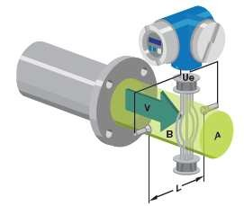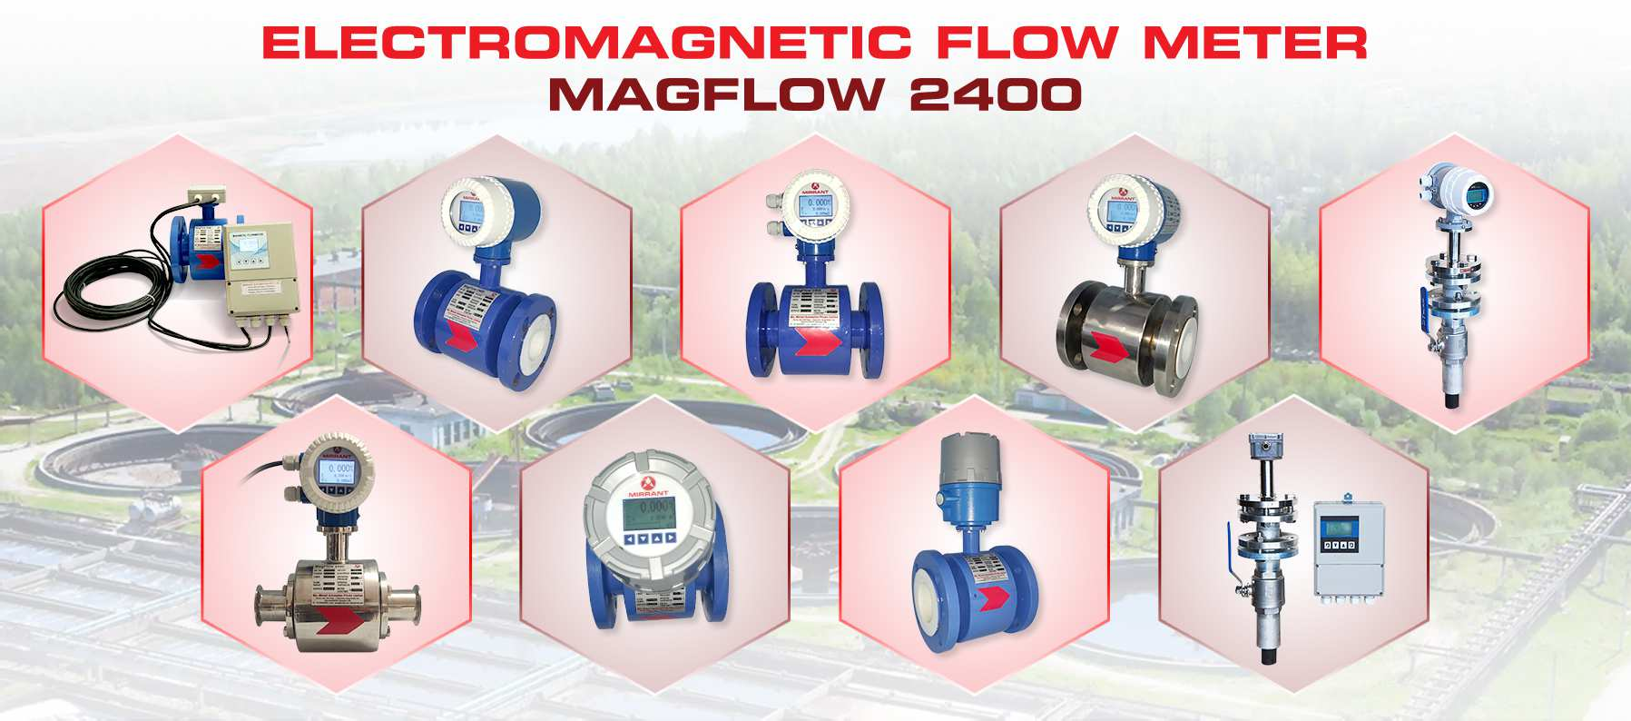

**ELECTROMAGNETIC FLOW METER**

ssss

# MagFlow 240

**0**

## Working Principle:

The working principle of a magnetic flow meter is based on Faraday’s law of electromagnetic induction. According to Faraday’s law, when the conductive fluid flows through a magnetic field of the sensor, an electromotive force proportional to the volume flow is generated be- tween the pair of electrodes, which is perpendicular to the flow direction and the magnetic field. The amplitude of the electromotive force can be expressed as:

**E = kBDv**

Where E:Induced electric potential, K: constant,

B:Magnetic flux density,

D:The inner diameter of the measuring Tube,

V:The average velocity of the fluid in the axial direction of the electrode cross-section inside the measuring tube.

***Sense. Automate. Integrate***

**MIRRANT AUTOMATION PRIVATE LIMITED**

Plot No:6A/5,IDA Phase-I, Patancheru, Phone: +91 9949306860 Sangareddy Dist.,Hyderabad-502032 Email: [sales@mirrant.com](mailto:sales@mirrant.com) Telangana, India Website: [www.mirrant.com](http://www.mirrant.com/)



**ELECTROMAGNETIC FLOW METER**

ssss

# MagFlow 240

**0**

## Features:

1. Measurement result will not be affected by change of density, viscosity, temperature, pressure and conductive rate
2. Product with good anti-corrosion and abrasion resistance performance
3. Full digital process, strong anti-interference performance, operating reliable with high accuracy and wide range of flow rate
4. Super low voltage EMI switch power supply, which could ensure fast response for voltage changes and good resistance on EMI
5. LCD Displays Flow Rate, Totaliser,Alarms,Analog output. All Standard Engineering Units in m3.Litre,Gallon,ft3
6. Product is manufactured with SMD devices and SMT technology, which provides high reliability circuits.
7. With self checking and diagnosis function and IOT Ready-AMR Network.

## Specifications:

|  |  |
| --- | --- |
| **MagFlow 2400 Electromagnetic flow meter** | |
| Medium | Domestic water, industrial water, raw water, ground water, urban sewage, industrial waste water, Processed neutral pulp, pulp slurry, Chemicals etc. |
| Diameter | DN10~DN2000mm |
| Accuracy | ±0.5% |
| Repeatability | ±0.2% of Span |
| Medium temperature | ＜180'C |
| Medium pressure (Kg/Cm2) | 10,16,25,40 |
| Flow rate | 0.3～10m/s |
| Electrode Material | SS316 Std.,Hastalloy C,Titanium,Tantalum,Platinum,etc |
| Lining Material | PTFE,Rubber,Neoprene,PFA,HDPE,Polyurethane,CPVC etc |
| Flow Tube Material | SS304 Std,SS316 |
| Coil House Material | Carbon steel,Stainless steel |
| Power supply | 230VAC,24VDC,Battery |
| Signal output | 4～20mA, Pulse and Relay |
| Communication Interface | RS485,GSM/GPRS,HART,LORA |
| Display | LCD Display In Engg.Units |
| Protection proof | IP65; IP67,IP68 |
| Flow Transmitter | Integral, Remote |
| Enclosure Material | Die Cast Aluminium |
| Electrical Connection | 1/2" NPT |
| Work environment | Ambient temperature：-20～+60□，Ambient humidity：5%～90% |
| End Connection | Flange-end, Wafer, Tri-Clover etc. |

***Sense. Automate. Integrate***

**MIRRANT AUTOMATION PRIVATE LIMITED**

Plot No:6A/5,IDA Phase-I, Patancheru, Phone: +91 9949306860 Sangareddy Dist.,Hyderabad-502032 Email: [sales@mirrant.com](mailto:sales@mirrant.com) Telangana, India Website: [www.mirrant.com](http://www.mirrant.com/)

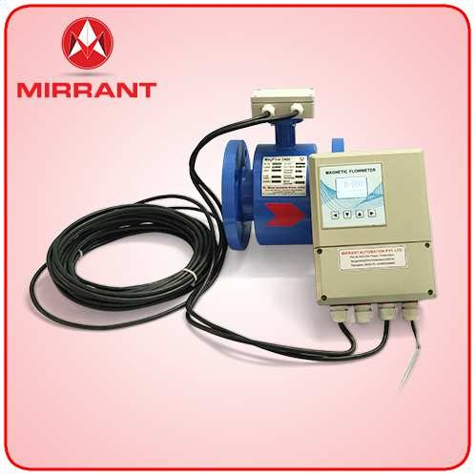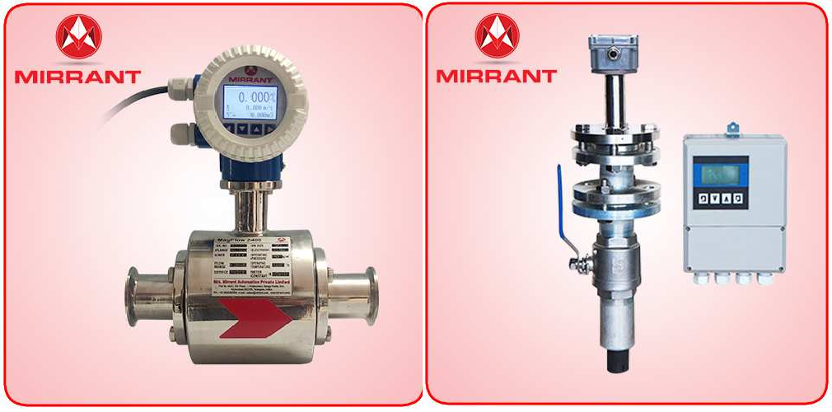

**ELECTROMAGNETIC FLOW METER**

ssss

# MagFlow 240

**0**

## Flow Table:

|  |  |  |  |  |  |  |  |  |  |
| --- | --- | --- | --- | --- | --- | --- | --- | --- | --- |
| **Size (D)** | | **m3/h** | | **LPM** | | **LPS** | | **GPM** | |
| **mm** | **inch** | **Min.** | **Max.** | **Min.** | **Max.** | **Min.** | **Max.** | **Min.** | **Max.** |
| 10 | 3/8" | 0.08 | 2.83 | 1.41 | 47.10 | 0.02 | 0.79 | 0.37 | 12.44 |
| 15 | 1/2" | 0.19 | 6.36 | 3.18 | 106.03 | 0.05 | 1.77 | 0.84 | 28.01 |
| 20 | 3/4" | 0.34 | 11.31 | 5.66 | 188.50 | 0.09 | 3.14 | 1.49 | 49.80 |
| 25 | 1" | 0.53 | 17.67 | 8.84 | 294.50 | 0.15 | 4.91 | 2.33 | 77.81 |
| 32 | 1-1/4" | 0.87 | 28.95 | 14.48 | 482.50 | 0.24 | 8.04 | 3.82 | 127.48 |
| 40 | 1-1/2" | 1.36 | 45.24 | 22.63 | 754.00 | 0.38 | 12.57 | 5.98 | 199.21 |
| 50 | 2" | 2.12 | 70.69 | 35.35 | 1178.17 | 0.59 | 19.64 | 9.34 | 311.27 |
| 65 | 2-1/2" | 3.58 | 119.50 | 59.73 | 1991.67 | 1.00 | 33.19 | 15.78 | 526.20 |
| 80 | 3" | 5.43 | 181.00 | 90.48 | 3016.67 | 1.51 | 50.28 | 23.91 | 797.01 |
| 100 | 4" | 8.48 | 282.70 | 141.38 | 4711.67 | 2.36 | 78.53 | 37.35 | 1244.83 |
| 125 | 5" | 13.26 | 441.80 | 221.00 | 7363.33 | 3.68 | 122.72 | 58.39 | 1945.40 |
| 150 | 6" | 19.09 | 636.20 | 318.17 | 10603.33 | 5.30 | 176.72 | 84.06 | 2801.41 |
| 200 | 8" | 33.93 | 1131.00 | 565.50 | 18850.00 | 9.43 | 314.17 | 149.41 | 4980.18 |
| 250 | 10" | 53.02 | 1767.00 | 883.67 | 29450.00 | 14.73 | 490.83 | 233.47 | 7780.71 |
| 300 | 12" | 76.35 | 2545.00 | 1272.50 | 42416.67 | 21.21 | 706.94 | 336.20 | 11206.52 |
| 350 | 14" | 92.37 | 3079.00 | 1539.50 | 51316.67 | 25.66 | 855.28 | 406.74 | 13557.90 |
| 400 | 16" | 135.80 | 4524.00 | 2263.33 | 75400.00 | 37.72 | 1256.67 | 597.97 | 19920.74 |
| 450 | 18" | 171.80 | 5726.00 | 2863.33 | 95433.33 | 47.72 | 1590.56 | 756.49 | 25213.56 |
| 500 | 20" | 212.10 | 7069.00 | 3535.00 | 117816.67 | 58.92 | 1963.61 | 933.95 | 31127.26 |
| 600 | 24" | 305.40 | 10180.00 | 5090.00 | 169666.67 | 84.83 | 2827.78 | 1344.78 | 44826.07 |
| 700 | 28" | 415.00 | 13850.00 | 6916.67 | 230833.33 | 115.28 | 3847.22 | 1827.39 | 60986.35 |
| 800 | 32" | 542.00 | 18100.00 | 9033.33 | 301666.67 | 150.56 | 5027.78 | 2386.61 | 79700.57 |
| 900 | 36" | 662.00 | 22900.00 | 11033.33 | 381666.67 | 183.89 | 6361.11 | 2915.02 | 100836.64 |
| 1000 | 40" | 848.00 | 28260.00 | 14133.33 | 471000.00 | 235.56 | 7850.00 | 3734.04 | 124438.57 |

***Sense. Automate. Integrate***

**MIRRANT AUTOMATION PRIVATE LIMITED**

Plot No:6A/5,IDA Phase-I, Patancheru, Phone: +91 9949306860 Sangareddy Dist.,Hyderabad-502032 Email: [sales@mirrant.com](mailto:sales@mirrant.com) Telangana, India Website: [www.mirrant.com](http://www.mirrant.com/)

**ELECTROMAGNETIC FLOW METER**

ssss



**MagFlow 240**

**0**

Ordering Code: MagFlow 2400:

|  |  |  |  |  |  |  |  |  |  |  |  |  |  |  |  |  |
| --- | --- | --- | --- | --- | --- | --- | --- | --- | --- | --- | --- | --- | --- | --- | --- | --- |
| **MagFlow 2400-** | **0025** | **M1** | **N1** | **L1** | **E1** | **H1** | **T1** | **F1** | **G1** | **I** | **P1** | **S1** | **C1** | **A** | **N** | **Description** |
| **Sensor Size** | **XXXX** |  |  |  |  |  |  |  |  |  |  |  |  |  |  | **DN10-DN2000 (mm)**  10,15,20,25,40,50,65,80,100,125,150,  200,250,300,350,400,450,500,600,700,  800,900,1000,1200,1400,1600,1800,  2000.., |
| **End Connection Type** | | **M1** |  |  |  |  |  |  |  |  |  |  |  |  |  | Flange-end |
| **M2** |  |  |  |  |  |  |  |  |  |  |  |  |  | Wafer |
| **M3** |  |  |  |  |  |  |  |  |  |  |  |  |  | Tri-Clover / SMS |
| **M4** |  |  |  |  |  |  |  |  |  |  |  |  |  | Insertion |
| **M5** |  |  |  |  |  |  |  |  |  |  |  |  |  | Any Other.. |
| **Nominal Pressure Rating** | | | **N1** |  |  |  |  |  |  |  |  |  |  |  |  | 5 Kg/cm2 |
| **N2** |  |  |  |  |  |  |  |  |  |  |  |  | 10 Kg/cm2 |
| **N3** |  |  |  |  |  |  |  |  |  |  |  |  | <40 Kg/Cm2 |
| **N4** |  |  |  |  |  |  |  |  |  |  |  |  | Any Other.. |
| **Lining Material** | | | | **L1** |  |  |  |  |  |  |  |  |  |  |  | PTFE |
| **L2** |  |  |  |  |  |  |  |  |  |  |  | Rubber |
| **L3** |  |  |  |  |  |  |  |  |  |  |  | PFA |
| **L4** |  |  |  |  |  |  |  |  |  |  |  | Any Other.. |
| **Electrode Material** | | | | | **E1** |  |  |  |  |  |  |  |  |  |  | SS316 |
| **E2** |  |  |  |  |  |  |  |  |  |  | SS316L |
| **E3** |  |  |  |  |  |  |  |  |  |  | Hastelloy C |
| **E4** |  |  |  |  |  |  |  |  |  |  | Any Other.. |
| **Coil Housing Material** | | | | | | **H1** |  |  |  |  |  |  |  |  |  | CS |
| **H2** |  |  |  |  |  |  |  |  |  | SS304 |
| **H3** |  |  |  |  |  |  |  |  |  | SS316 |
| **H4** |  |  |  |  |  |  |  |  |  | Any Other.. |
| **Flow Tube Material** | | | | | | | **T1** |  |  |  |  |  |  |  |  | SS304 |
| **T2** |  |  |  |  |  |  |  |  | SS316 |
| **T3** |  |  |  |  |  |  |  |  | Any Other.. |
| **Flange Material** | | | | | | | | **F1** |  |  |  |  |  |  |  | CS |
| **F2** |  |  |  |  |  |  |  | SS304 |
| **F3** |  |  |  |  |  |  |  | SS316 |
| **F4** |  |  |  |  |  |  |  | Any Other.. |
| **Grounding Rings Material** | | | | | | | | | **G1** |  |  |  |  |  |  | Not Applicable |
| **G2** |  |  |  |  |  |  | SS316 |
| **G3** |  |  |  |  |  |  | SS316L |
| **G4** |  |  |  |  |  |  | Any Other.. |
| **Flow Transmitter** | | | | | | | | | | **I** |  |  |  |  |  | Integral |
| **R** |  |  |  |  |  | Remote |
| **Power Supply** | | | | | | | | | | | **P1** |  |  |  |  | 85-265V AC |
| **P2** |  |  |  |  | 24V DC |
| **P3** |  |  |  |  | 3.6V lithium battery |
| **P4** |  |  |  |  | Any Other.. |
| **Signal Output** | | | | | | | | | | | | **S1** |  |  |  | 4-20mA DC, Pulse & 2 Relays (Alarm) |
| **S2** |  |  |  | Any Other.. |
| **Communication Protocol** | | | | | | | | | | | | | **C1** |  |  | Modbus RS485 |
| **C2** |  |  | HART |
| **C3** |  |  | GSM/GPRS |
| **C4** |  |  | Any Other.. |
| **Enclosure Class** | | | | | | | | | | | | | | **A** |  | IP 65 |
| **B** |  | IP 67 |
| **C** |  | IP 68 |
| **Approval** | | | | | | | | | | | | | | | **N** | Not Applicable |
| **F** | Flame Proof (FLP) |

***Sense. Automate. Integrate***

**MIRRANT AUTOMATION PRIVATE LIMITED**

Plot No:6A/5,IDA Phase-I, Patancheru, Phone: +91 9949306860 Sangareddy Dist.,Hyderabad-502032 Email: [sales@mirrant.com](mailto:sales@mirrant.com) Telangana, India Website: [www.mirrant.com](http://www.mirrant.com/)